Software Design Document

Sydney Airbnb Data Analysis Tool

s5291506 – Jamil Deris  
s5287914 – Tanish Dhir  
s5295636 – Arjan Dangol

Table of Contents

1.0 System Vision 3

1.1 Problem Background 3

1.2 System Overview 3

1.3 Potential Benefits 3

2.0 Requirements 4

2.1 User Requirements 4

2.2 Software Requirements 4

2.3 Use Cases 4

3.0 System Components and Software Design 5

3.1 System Components 5

3.2 Software Design 5

4.0 User Interface Design 6

# System Vision

## Problem Background

The purpose of the Sydney Airbnb Data Analysis Tool is to provide users with a user interface, for analysing and visualising data from the Sydney Airbnb dataset. This tool allows users to explore aspects such as listings, prices, amenities, and cleanliness factors in order to gain insights into the Sydney Airbnb market.

## System Overview

The system is a software application that enables users to interact with the Sydney Airbnb dataset using a user interface (GUI). Through this GUI users can perform functions for data analysis and visualisation. These functionalities include retrieving information about listings generating charts depicting price distribution searching for keywords analysing comments related to cleanliness and discovering insights.

## Potential Benefits

Real estate professionals can utilise this tool to understand pricing trends across suburbs. Travel enthusiasts can easily find properties based on amenities like pools, pet friendliness, furnished accommodations, locations etc.  
Airbnb hosts have the opportunity to analyse cleanliness related comments in order to enhance their listings. Researchers can extract insights, into customer preferences and behaviour within the Airbnb market.

# Requirements

## User Requirements

The client wants to provide good staying services to customers want this tool, to enable customers have various options to stay when they visit Sydney. This will be helpful for room owners as this can help them to improve their services. The software feature of producing a chart of pricing can help research and surveys to see trend of pricing of rooms as well as which month has more visitors in Sydney.

Client wants detailed listing of rooms, features, cost, feedback when customer searches for an area. The search should show rooms based on filter what customer enter by default it should present rooms with good feedback. There should be filter options like cost, feedback, list date.

## Software Requirements

R1.1 The program shall accept user input through a list of suburbs.

R1.2 The program shall show what rooms are available and show brief description about them.

R1.3 It shall have a date option to see for a particular date.

R1.4 It shall present a price for each room including details of payment.

R1.5 It shall display feedback chart of a room on basis of cleanliness, market, public transport, attractions. These will have values which indicate what is the review of the room. These are selected as tourists will look for these features in a room as it makes their visit a pleasant experience.

R1.6 The program shall present a price distribution chart when user selects a suburb and click on view price distribution chart.

R1.7 The program shall present how many times a property has been used for a user selected date.

## Use Cases & Use Case Diagrams

In this section, some use cases are provided to show how individuals may utilise the software.

|  |  |
| --- | --- |
| Use Case ID | 1 |
| Use Case Name | View Listings |
| Actors | User |
| Description | Users will be able to view the rooms in one suburb at a given time. |
| Normal Flow | 1. User goes to the program website. 2. Selects time period. 3. Selects a suburb in the list. 4. Program shows all the rooms. |
| Alternate Flow | None |

|  |  |
| --- | --- |
| Use Case ID | 2 |
| Use Case Name | View price distribution chart |
| Actors | User |
| Description | Users will be able to view the room prices in chart form in one suburb |
| Normal Flow | 1. User goes to the program website. 2. Selects time period. 3. User clicks on show price chart button. 4. Program creates a chart of prices of rooms. |
| Alternate Flow | None |

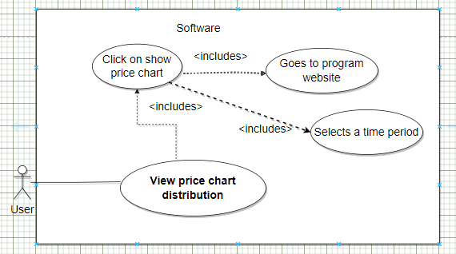

|  |  |
| --- | --- |
| Use Case ID | 3 |
| Use Case Name | View user specific rooms |
| Actors | User |
| Description | Users will be able to view the rooms with desired features |
| Normal Flow | 1. User goes to the program website. 2. Select time period 3. Selects a suburb in the list. 4. Program lists all the rooms. 5. User then type words like pool, spa and other words, then select search button. 6. Rooms with user entered word are presented. |
| Alternate Flow | None |

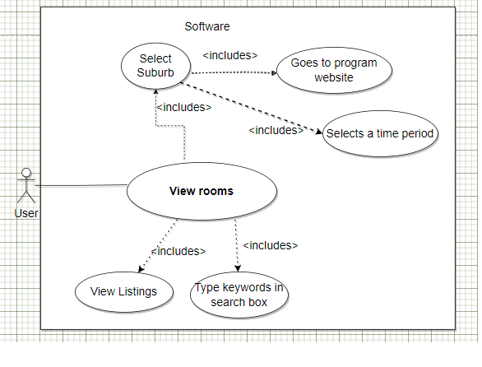

|  |  |
| --- | --- |
| Use Case ID | 4 |
| Use Case Name | View review chart |
| Actors | User |
| Description | Users will be able to see the feedback of rooms in a chart form. |
| Normal Flow | 1. User goes to the program website. 2. Selects a suburb in the list. 3. Program shows all the rooms. 4. User selects a room. 5. Clicks on show review chart. 6. Displays the total number of reviews. 7. Program shows chart of the room. |
| Alternate Flow | None |

|  |  |
| --- | --- |
| Use Case ID | 5 |
| Use Case Name | Show number of times a property has been used |
| Actors | User |
| Description | Users will be able to see how many times a property has been used. |
| Normal Flow | 1. User goes to the program website. 2. Selects a suburb in the list. 3. Program shows all the rooms. 4. User selects a room. 5. There is information about number of times that room has been used. |
| Alternate Flow | None |

# Software Design and System Components

## Software Design

Figure : Software design of the system

The figure demonstrated above represents a block diagram of the software design. It consists of all the essential components interconnected with each other showing the workflow within the system. Here user can extract the listing/visualisation of data from the Sydney Airbnb open dataset in the system. This system meets all the user requirements mentioned above. In the block diagram, the search engine represents a mechanism through which all the user’s action (select suburb, select period, search keyword, select room) is processed with the Sydney Airbnb dataset giving out the required responses. The responses are then represented as simple listings or visualisation.

## System Components

### Functions

1. **view_listing(suburb_name: string, date_from: datetime, date_to: datetime)**: Stores listings of all the rooms available in a specific suburb with the provided name of that suburb and a period (date range).
   * Input: suburb_name (name of that suburb or area), date_from (starting date), date_to (end date)
   * Side effects: Updates the listings variable with the results in the system.
   * Return Value: Listings in a specified suburb with selected columns.
2. **create_pricing_chart(column_name: string, date_from: datetime, date_to: datetime)**: Creates a visualisation chart showing the distribution of prices amongst all the properties with user specified date range.
   * Input: column_name (here column_name is “price”), date_from, date_to
   * Side effects: Creates a chart based on the distribution of the prices.
   * Return Value: A chart showing the distribution of prices.
3. **view_user_specific_rooms(keyword: string, date_from: datetime, date_to: datetime)**: Creates listings of all the rooms that consists of the keyword and date range specified by the user.
   * Input: keyword, date_from, date_to
   * Side effects: Update the listings respective to the filtered data through selected keyword.
   * Return Value: All the records containing the specified keyword.
4. **view_review_chart(listing_id: integer, keyword: string)**: Creates a visualisation chart displaying number of customers commented in a specific property (i.e., listing_id) relevant to specified keyword.
   * Input: listing_id, keyword
   * Side effects: Updates the listing reviews variable.
   * Return Value: A record of comments on selected property and keywords leading to visualisation chart.
5. **view_property_used_times(listing_id: integer, date_from: datetime, date_to: datetime)**: Displays the number of times that property has been used within user specified date range.
   * Input: listing_id, date_from, date_to
   * Side effects: Updates the listing data with total number of the specific listing used.
   * Return Value: Number (total number indicating the use of that room).

### Data Structures / Data Sources

1. **listings:** 
   * It is an **array** of objects with different columns regarding the Sydney Airbnb dataset.
   * It consists of list of objects that has data members such as, **id**, **listing_url**, **name**, **description**, **street**, **city**, **state**, **zipcode**, **country**, **price**, etc.
   * It is used in every function to filter or extract user specific data.
2. **listing_data:** 
   * It is an **object** data structure that consists of different columns.
   * It consists of data members such as, **id, listing_url, name, description, street, city, state, zipcode, country, price,** etc.
   * The functions that use this data are: **view_property_used_times()** and **view_review_chart()**.
3. **listing_reviews:** 
   * It is an **array** of objects with specified listing_id and its reviews in each object.
   * It consists of list of objects that has data members such as, **listing_id, id, date, reviewer_id, reviewer_name**, and **comments**.
   * This is the data that is retrieved by using **view_review_chart()** function.
4. **keyword:** 
   * It is a **string** that holds data specified by the user.
   * The functions that use this data are: **view_user_specific_rooms(),** and **view_review_chart().**
5. **date_from:** 
   * It is a **datetime** data structure which represents the start date of the period to extract the listings.
   * The functions that use this data are: **view_listing (), create_pricing_chart(), view_user_specific_rooms(), view_review_chart(),** and **view_property_used_times().**
6. **date_to:** 
   * It is a **datetime** data structure which represents the end date of the period to extract the listings.
   * The functions that use this data are: **view_listing (), create_pricing_chart(), view_user_specific_rooms(), view_review_chart(),** and **view_property_used_times().**
7. **column_name:** 
   * It is a **string** data structure that represents the specific column of the actual dataset which needs to be extracted.
   * The function that uses this data is **create_pricing_chart().**
8. **listing_id:** 
   * It is an **integer** that represents the unique identifier for a specific property.
   * The functions that use this data are: **view_review_chart(),** and **view_property_used_times().**
9. **suburb_name:** 
   * It is a **string** type that represents the specific name of the suburb of which the listings are needed to be extracted.
   * The function that uses this data is **view_listing ().**

### Detailed Design

1. Algorithm: UserSpecificRooms
   * Input: keyword, date_from, date_to
   * Output: Filtered listings (with user specified keywords in them)
   * Pseudocode:
     1. Initialize variables: listings = [], specific_keyword_listings = []
     2. Select suburb, start date, and end date to call view_listing function (with listings CSV file).
     3. Store the data in listings variable.
     4. Filter the listings data with the specified keyword:
        + - Push the object containing specified keywords to the specific_keyword_listings array.
     5. If length of specific_keyword_listings is greater than 0:
        + Return specified_keyword_listings.
     6. Else:
        + Return 0 (i.e., there are no rooms relevant to the specified keyword)
     7. End.
2. Algorithm: CreatePricingChart
   * Input: ColumnName, DateFrom, DateTo
   * Output: Visualisation Chart (listing_id, name, and price)
   * Pseudocode:
     1. Initialize variable: listings = []
     2. Select start date, and end date to call view_listing function (with listings CSV file).
     3. Store the data in listings variable.
     4. Map listings data with column_name as “price” to visualisation chart library in python.
     5. Display the chart with data formed in ascending format.
     6. End.
3. Algorithm: ViewReviewChart
   * Input: listing_id, keyword
   * Output: Total number of comments
   * Pseudocode:
     1. Initialize variables: reviews_listings = [], filtered_listings = [], specific_keyword_listings = [], total_reviews = 0
     2. Select start date, and end date to call view_listing function (with reviews CSV file).
     3. Store the data in reviews_listings variable.
     4. Filter the reviews_listings data with specified listing_id:
        + Push the object containing specified listing_id to the filtered_listings array.
     5. Filter the filtered_listings data against comments column with the specified keyword:
        + - Push the object containing specified keywords to the specific_keyword_listings array.
     6. If length of specific_keyword_listings is greater than 0:
        + Calculate the length of specific_keyword_listings array.
        + Store it in total_reviews variable.
        + Return total_reviews.
     7. Else:
        + Return 0 (i.e., there are no comments relevant to the specified keyword)
     8. End.
4. Algorithm: ViewPropertyUsedTimes
   * Input: ListingId, DateFrom, DateTime
   * Output: TotalUsedTimes
   * Pseudocode:
5. Initialize variables: total_used_times = 0, listings = [], listing_id = null
6. Select suburb, start date, and end date to call view_listing function (with listings CSV file).
7. Store the data in listings variable.
8. Select listing_id and store it in listing_id variable.
9. Loop through each row in the listings data for the selected listing_id:
   * + Increment total_used_times.
     + If total_used_times is greater than 0:
       - Return total_used_times.
     + Else:
       - Return 0 (i.e., that room hasn’t been used in the specified variables).
10. End.

# User Interface Design

To develop the user interface design, for the Sydney Airbnb Data Analysis Tool we utilized a mix of wireframing tools and design software called Lucid chart to generate a design. Our design was influenced by the user requirements. Use cases described in sections. Our objective was to create a user intuitive interface that enables effortless data interaction and facilitates analyses.

**Overall Design Principles**

* **Consistency:** The design of the user interface ensures an arrangement, colour palette and typography, across the tool resulting in a seamless user experience.
* **User-Friendly:** The focus of the design is to ensure that it is user friendly and easy to navigate allowing a diverse group of individuals to easily access it.
* **Responsive:** The interface is created in such a way that it's adaptable and functions smoothly, on both computers and mobile devices.
* **Accessibility:** We have integrated accessibility features, like adding text for images and enabling keyboard navigation to ensure that everyone can use the tool effectively.
* **Feedback:** Users are provided with notifications and messages to assist them in utilising the tool.
* **Data Visualisation:** Charts and graphs are commonly utilised to present data in a way that's easy for people to comprehend.

## Structural Design

**4.1.1 Introduction Page**The introduction page acts as the starting point, for users. Offers an overview of what the tool can do. It consists of the following components:

* **Header:** The header displays the logo of the tool and a navigation menu allowing users to access sections within the tool.
* **Title:** A succinct title that conveys the purpose of the tool; "Sydney Airbnb Data Analysis Tool."
* **Search Form:** A search form where users can choose a suburb date range and apply filters to conduct their analysis. This form is crucial for meeting user requirements.
* **Benefits Section:** A segment that highlights the advantages of utilizing this tool for different user categories, including real estate professionals, travellers, Airbnb hosts and researchers.
* **Get Started Button:** An eye-catching call, to action button that motivates users to initiate their analysis.

**4.1.2 The view for Listing**The Listings View is the place where users can explore rooms that're available in a suburb and within a particular date range. It consists of the following elements:

* **Search Filters:** Users have the option to refine their search by choosing a suburb specifying a date range and applying filters like cost, feedback and listing date. These filters are conveniently organized in a sidebar for access.
* **Display of Listings:** A list showcasing all the rooms within the chosen suburb and date range is presented. Each listing provides details such, as the rooms name, description, price, and feedback rating. Clicking on any listing will provide users with information.
* **Pagination:** In case there are listings to browse through pagination controls enable users to navigate through the results easily.

**4.1.3 The Price Distribution**  
The Price Distribution Chart section allows users to visually see how room prices are distributed in a suburb and period. It includes the following components:

* **Chart Display:** A chart that illustrates the distribution of room prices. Users have the option to customize the chart by selecting different date ranges.
* **Date Range Selector:** Users can choose the timeframe for which they would like to view the price distribution.

**4.1.4 User Customised Rooms**Within the section dedicated to User Rooms users can search for rooms based on features or keywords. This section consists of the following elements:

* **Search Input:** Users can input keywords (“pool," "spa") to find rooms that possess the desired features. Additionally, there is an option to specify a date range.
* **Listing Display:** The search results are presented, showcasing rooms that meet the criteria.

**4.1.5 Review Chart**In the Review Chart section users have the option to check out feedback and reviews regarding a room. This section comprises the following components:

* **Room Selection:** Users can choose a room, from the list provided to access its reviews.
* **Review Chart Display:** A representation that showcases the count of customer comments addressing cleanliness, market accessibility, public transportation options and nearby attractions, for the chosen room.

**4.1.6 Usage Data for Properties**Within the Usage Data for Properties section users can review the frequency at which a particular property has been utilized during a specified period. This section encompasses the following elements:

* **Room Selection:** Users may choose a room, from the list of options to access its corresponding usage data.
* **Display of Usage Statistics:** Details pertaining to how the selected property has been utilized within the designated date range.

Figure : Structural Design

## Visual Design

Here is a detailed visual design:

**Layout:**

* The system’s layout will be well structured and neatly organized, with a design that adjusts seamlessly to screen sizes.
* The top navigation bar will remain fixed making it easy for users to access links to specific requirements.

**Visual Elements:**

* Property listings and search results will be displayed in tables, charts, and separate container views.
* Clear and concise labels and headings will guide users through the interface.
* Interactive buttons will have shadows or a slight raised effect to indicate their click-ability.
* The selected menu item will have distinct border colour to determine active page.

**Icons and Graphics:**

* We will use recognizable icons to represent functionality of system like search, date range, suburb, etc.
* Graphics will be used sparingly to enhance the visual appeal without overwhelming the overall interface.

**Style:**

* The design style we will follow is modern and minimalistic focusing on simplicity and clarity.
* Rounded corners on cards and inputs will give a look to the design.

**Colour Palette:**

* Our colour palette primarily consists of blues and greens which create an ambiance. Shades of blue convey trustworthiness and professionalism while green represents tranquillity and growth.

**Fonts:**

* For body text it's important to use a sans serif font that's easy to read on devices.
* Consider using a complementary sans serif font with a hint of elegance, for headings and titles.
* We will use sans serif for all the text in the interface so that it could be easy to read.
* Different sizes and weight will be used to create distinction within the interface (such as for, title, table heading, descriptions, etc).

A simple wireframe of our whole system is represented below with some description:

* + 1. **Introduction Page**

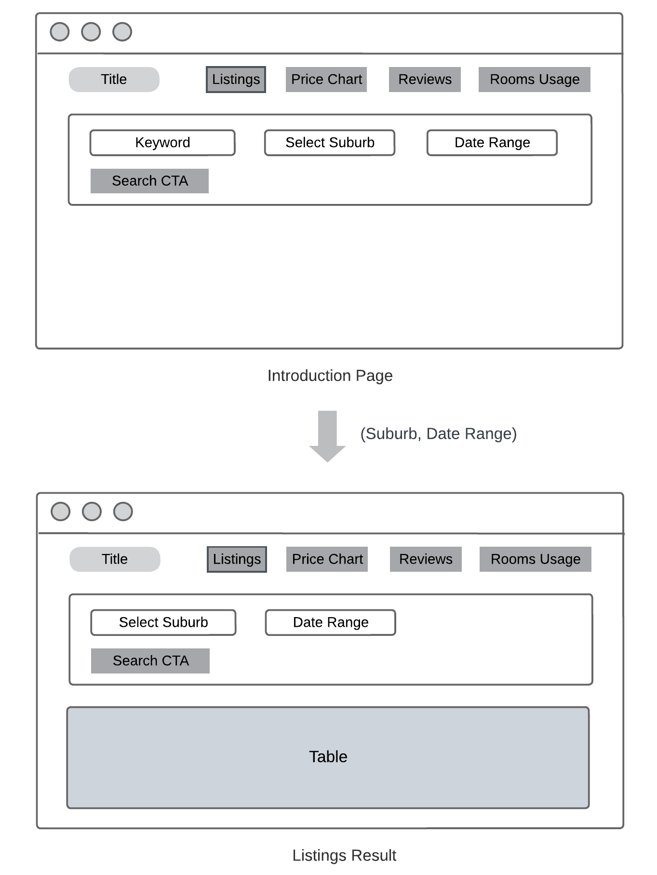

Figure : Introduction Page

In the introduction page:

* It consists of the title, menu items (all the required features), and a search area (with keyword, suburb, and date range selection).
* When the user selects suburb and changes the period, after pressing search button, a table with all the listings result is displayed.
  + 1. **Price Chart Page**

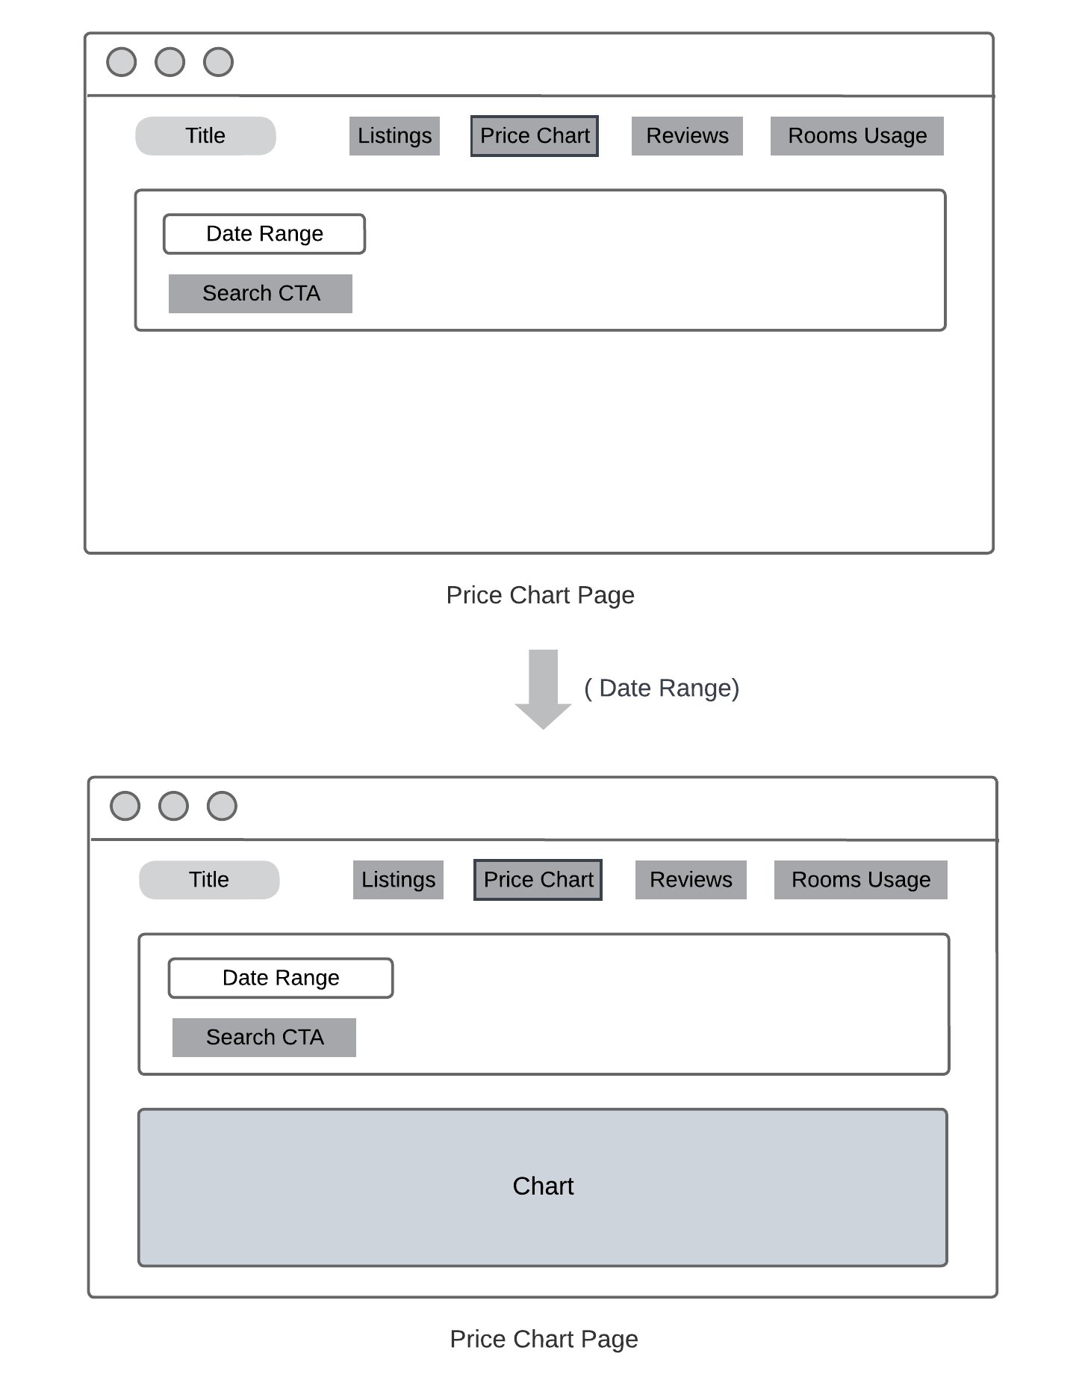

Figure : Price Chart Page

In the price chart page:

* It consists of the title, menu items (all the required features), and date range selection input.
* When the user changes the period, after pressing search button, a chart for the price distribution is displayed.
  + 1. **User Specific Page**

Figure : User Specific Page

In the user specific page:

* It consists of the title, menu items (all the required features), and a search area (with keyword, suburb, and date range selection).
* When the user selects keyword, suburb and changes the period, after pressing search button, a table with all the listings result relevant to the keyword is displayed.
  + 1. **Reviews Page**

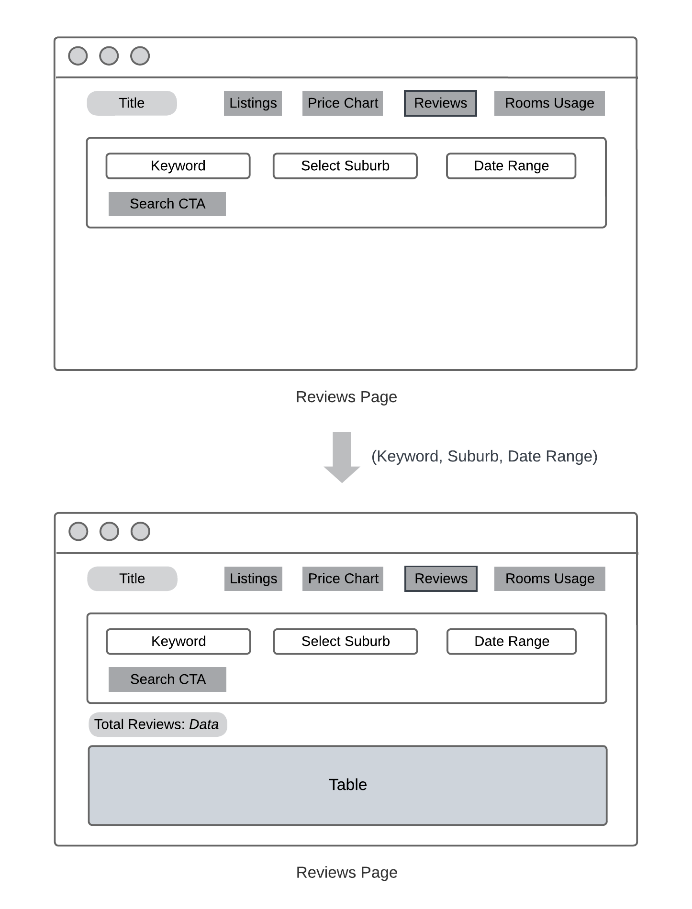

Figure : Reviews Page

In the reviews page:

* It consists of the title, menu items (all the required features), and a search area (with keyword, suburb, and date range selection).
* When the user selects suburb and changes the period, after pressing search button, a table with all the listings result is displayed.
* Then if user selects a specific listing id on table data, the detail of that room is displayed (consisting total numbers of reviews on that listing id of specific keyword).
  + 1. **Rooms Usage Page**

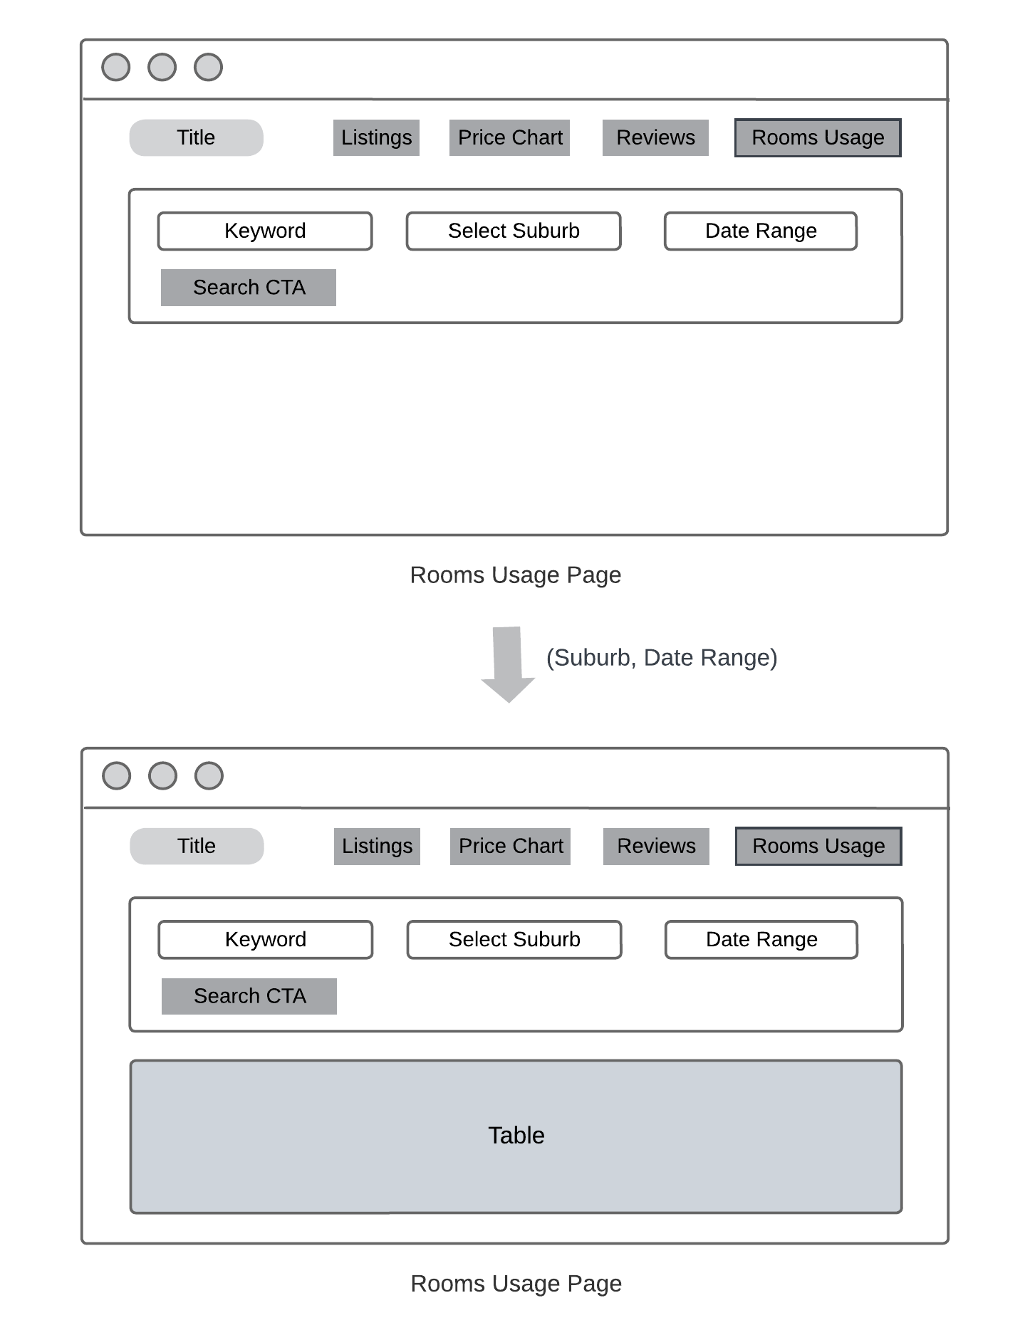

Figure : Rooms Usage Page

In the rooms usage page:

* It consists of the title, menu items (all the required features), and a search area (with keyword, suburb, and date range selection).
* When the user selects suburb and changes the period, after pressing search button, a table with all the listings result is displayed.
* Then if user selects a specific listing id on table data, the detail of that room is displayed (consisting total number of times of that room being used).